Dis-Eur-Female Figurine-Seated-Bulgaria, Stara Zagora

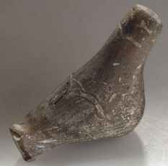

**Formal Label: Formal Label:** Bulgaria, Stara Zagora, Seated Female Figurine

**Accession Number:** A125

**Date or Time Horizon:** 6th millennium BCE

**Geographical Area:** Stara Zagora, Bulgaria

**Cultural Affiliation:** Neolithic

**Medium:** **terracotta colored with charcoal and red ochre, Fe2O3.;** Archaeological Museum in Stara Zagora **reproduction in ceramic, restored to original colors.**

**Dimensions:**

**Weight:**

**Provenance:** Archaeological Museum in Stara Zagora

**Condition:** Archaeological Museum in Stara ZagoraReplica

**Discussion:** This figurine dates to the beginning of farming in central Europe and the red ochre geometric markings probably emulated the shape of tattoos or body paint. The production of Stara Zagora ceramic figurines indicates that this was a sedentary society in which there was expendable time for producing amulets such as this for individuals.

**References:**

Grębska-Kulow, M. 2016. Prehistoric Anthropomorphic Figurines with Masks as the Basis for the Kuker’s Ritual in Bulgarian Folklore. In *The Intangible Elements of Culture in Ethnoarchaeological Research* (pp. 201-210). Springer International Publishing.